**PROJECT REPORT**

Project title: GIFT GALLARY

Type of project: Online Website on Gift Ideas

Introduction:

The Gift Gallary is a website for Analizing new ideas about GiftOn the basis on Occation, age or Relationships.It is really an Efficiant way for Buying Gifts for our relatives, calligs, etc. is nothing but creating multiple web pages. In these I used HTML,CSS,and Javascript.

Basic HTML for creating the webpage and CSS for design the layout of the webpage including some header,footer,background .Javascript are used for validation purpose in website.

Contents:

HTML:here in these language I used basic tags of HTML.like<html><body><head><marquee>

Basically marquee tag is used for images in my website.

CSS: In css, I used some headers,transperancy technique,font size,padding,all about the dimensions which are required for creating webpage I gave in the code.for background I used image by using background image tag.

Javascript: Javascript is mainly used for the validation purpose.here I used <script>tag for the java script.

**Screenshots:**

Homepage:

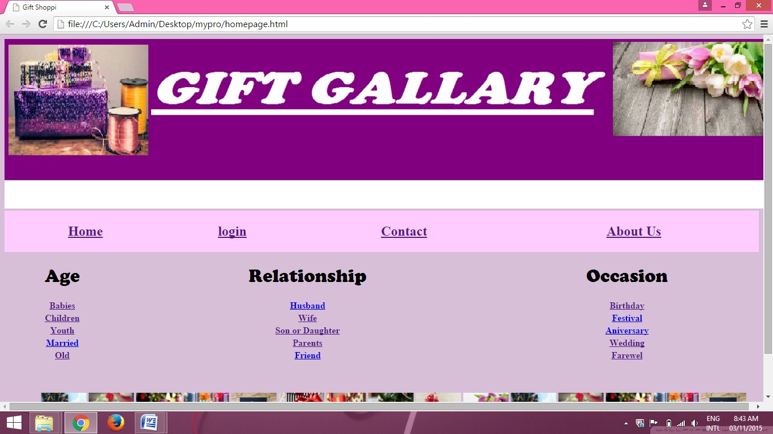

2.About Us Page: 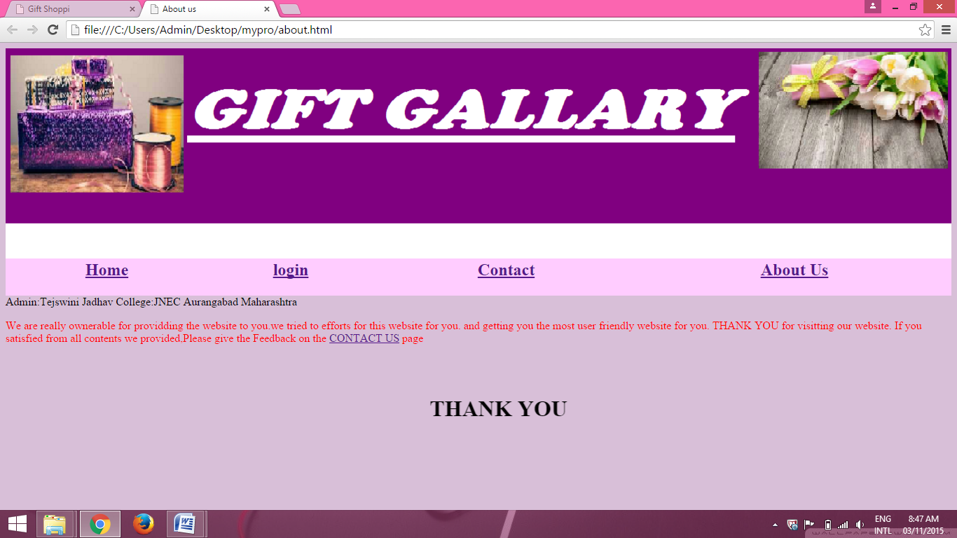

3. Contact page:

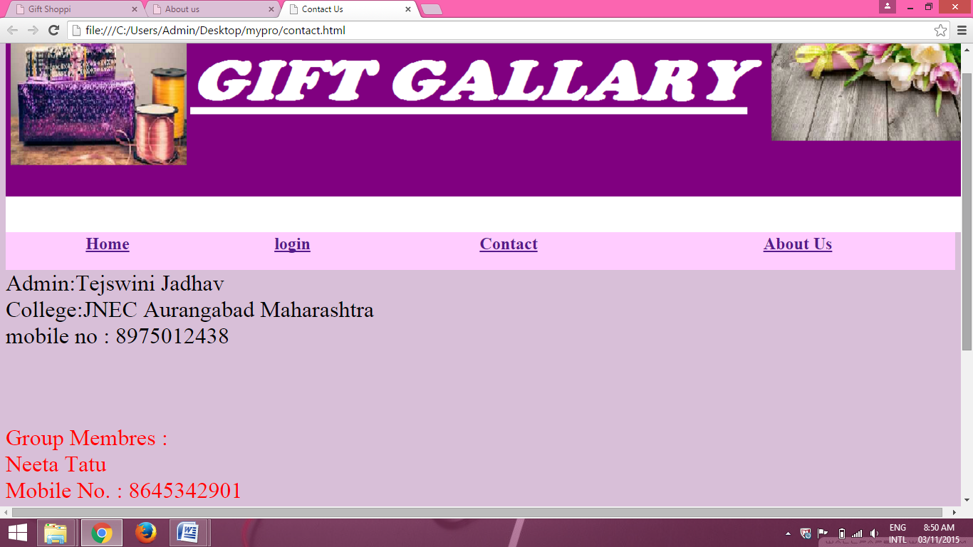

4. Registration Form page:

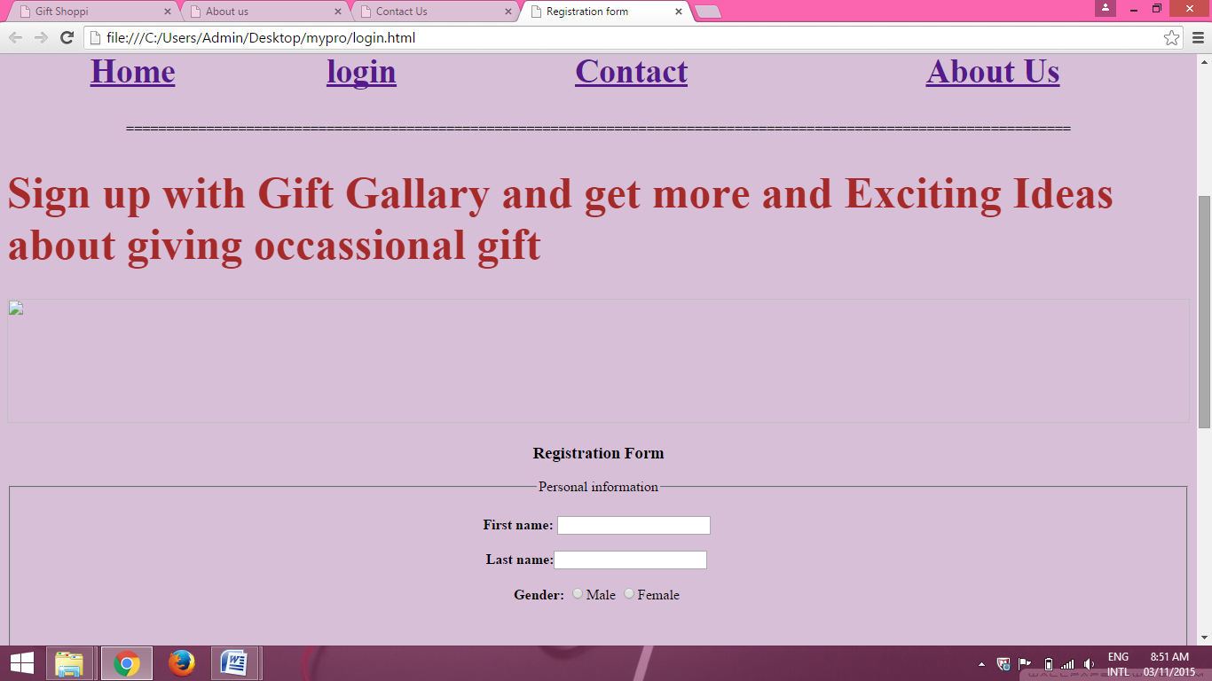

Conclusion: In this way the user can easily interact with my website. The user makes registration through website easily.